STATE OF THE DISABILITY SECTOR REPORT 2015
The NDIS is the right destination. To deliver on its promise providers need sufficient

Publisher

National Disability Services
Contact
Dr Ken Baker AM
Chief Executive, National Disability Services
Ph: 02 6283 3200
E: ken.baker@nds.org.au
Web: www.nds.org.au
All rights reserved. No part of this publication may be reproduced, distributed, or transmitted in any form without the prior written permission of the publisher. Except in the case of brief quotations embodied in critical reviews and certain other non-commercial uses permitted by copyright law.
About National Disability Services
National Disability Services is the peak industry body for non-government disability services. Its purpose is to promote life opportunities and quality service provision for people with disability. Its Australia-wide membership includes over 1,000 organisations, which support people with all forms of disability. Its members collectively provide the full range of disability services – from accommodation support, respite and therapy to community access and employment. NDS provides information and networking opportunities to its members and policy advice to State, Territory and Federal governments.

Table of Content

Introduction 4
NDS BUSINESS CONFIDENCE SURVEY 6
RISK 6
OPPORTUNITY 6
Key findings 6
NATIONAL DISABILITY INSURANCE SCHEME (NDIS) 7
Provider readiness for the NDIS 10
Providers are least prepared on costing and pricing 10
Key findings 11
Funding the NDIS 11
WORKFORCE SUSTAINABILITY 12
EMPLOYMENT SERVICES 13
POLICY AND RESEARCH 15
2016 TO-DO LIST 17

Introduction

The journey to the National Disability Insurance Scheme (NDIS) is gathering pace. 20,000 participants in seven states and territories now have an approved NDIS plan; a new site is commencing in northern Queensland; and bilateral agreements now outline how the NDIS will roll out across NSW and Victoria.
For disability service providers, the journey to the NDIS is arduous and uncertain. Providers don’t lack the will to proceed, but they do lack resources and a clear map of the terrain ahead.
This year’s release of strategies which outline the NDIS market architecture, the approach to purchasing assistive technology, the Information Linkages and Capacity-Building framework and rural and remote support provide some guidance. However, these strategies are high-level and require detailed action plans to give them practical meaning.
Other parts of the NDIS are still unknown, for example, the regulation of quality and safeguarding and some critical features of the design, such as pricing and housing, remain highly problematic.
The ultimate test of the NDIS will be how well it improves the lives of Australians with disability. There are early stories from the trial sites which give a glimpse of the beneficial impact the NDIS can have on the lives of participants and their families.
For these stories to become the norm across Australia, the NDIS must have a service sector that is dynamic, financially sustainable and rewards providers of high-quality supports. Consumer choice will help drive this, but it won’t be sufficient. There must be a well-tuned combination of pricing, regulation, expertise and commitment.
Sector development is a critical element in the transition to the NDIS. NDS is involved with many projects around Australia that are assisting providers to prepare for the new business environment ahead. The NDIS cannot afford to allow good not-for-profit providers to flounder because they lack business systems or marketing skills. The Australian Government’s Sector Development Fund should increase its strategic investments.
The NDIS is not the only destination on the horizon. The Australian Government is drafting plans to reform disability employment support. NDS has long argued that the disability employment system needs change. Australia’s low disability employment rate must improve.
At present, hundreds of pages of contractual rules tie up Disability Employment Service providers and participants in red tape, limiting flexibility and choice. A good start to reform would be to expand participant choice, person-centred planning, early intervention and capacity-building – all design principles central to the NDIS. Reform should not discard the current system, but rather build on its best features.
Australian Disability Enterprises (ADEs) are under financial pressure, which would be fatal for many if the push for a new wage assessment method imposed inflated wage costs on them. ADEs will evolve under the NDIS, but must remain a viable option for participants seeking employment.
Arguably the most ambitious of all the reforms is the National Disability Strategy. This ten-year strategy is endorsed by the heads of all governments – state, federal and local – and extends across all portfolios. So far, the Strategy’s impact has not lived up to its ambition. The new 2015-18 action plan (under development) will need to have much more horsepower than the previous plan if it is to drive real change. The Strategy requires a stronger accountability and performance framework.
There are divisions in the disability community and robust arguments between the disability sector and government. But on the big things there is broad consensus. We all want an NDIS that works well. We all want employment opportunities for people with disability to expand. We all want the rights and social inclusion of people with disability to be promoted across all domains of life. There is thus a strong basis to work together on overcoming the obstacles that impede progress. Negotiating agreement on contentious questions is not the easiest or the most direct route, but it is the surest way forward.
The NDIS is the right destination. It will double the funding for disability support, expand choice for people with disability and their families, invest in early intervention and replace a fragmented inequitable system with one that gives people across Australia access to reasonable and necessary supports.
But there are legitimate questions about how we get to this destination and at what pace; and how to turn the ambitious vision of the NDIS into reality. How can we create an NDIS that works well for everyone?
Ken Baker Chief Executive National Disability Services

NDS BUSINESS CONFIDENCE SURVEY

RISK
Without greater planning, investment and sector development from governments the disability services sector could become less diverse driving out organisations which innovate, are too small to compete or deliver specialised services.

OPPORTUNITY
Not-for-profit disability service providers are contributing significant social capital in the roll out of the NDIS including community volunteers and charitable donations. The NDIS has an opportunity to work with not-for-profit disability service providers to build upon this goodwill and social capital to deliver a more effective scheme.
In conjunction with independent research consultant BMG Research, NDS carried out a Business Confidence Survey to examine the disability sector’s ability to adjust to the changing environment. More than 424 of NDS’s 1000 members participated in the survey. The results offer an insight into sector confidence as well as the factors that are helping or constraining organisations in adapting to disability reforms.

Key findings
Business conditions are improving
Wave three 2015 results confirm that business confidence holds steady from 2014, with 64% of organisations expecting to meet their objectives in the next six months. Driven by improving business conditions, organisations are cautiously optimistic about the future:
46% of organisations report increased income, up from 36% in past surveys (17% report less income)
Governments should be more responsive
While 66% of organisations agree that the policy reforms are heading in the right direction:
Given the mix of opportunities and risks that the NDIS presents, it’s no surprise that service providers are divided on whether the NDIS roll out should be slowed down, with some very concerned about the way in which the scheme is being implemented.
9% are not focused on growth, due to concerns this will lead to reduction
12% expect to enter a merger within the next six months, up from 8% in 2014

NATIONAL DISABILITY INSURANCE SCHEME (NDIS)

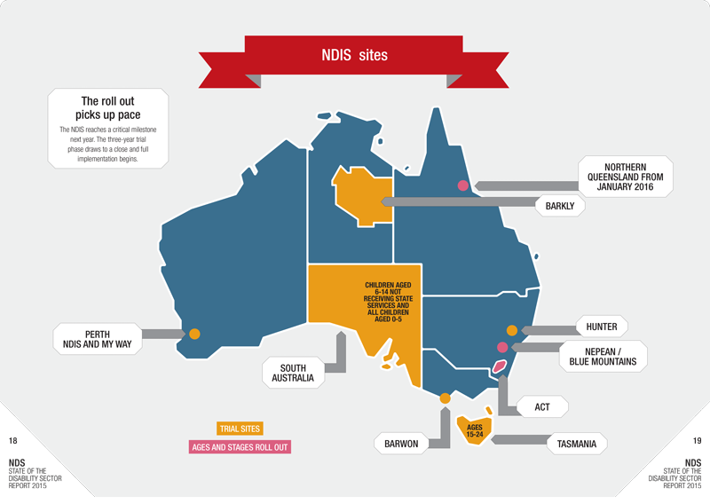

ISSUE | DETAILS | SOLUTION
Pricing | The NDIA wants the NDIS to operate within its funding envelope and deliver value for money. However, prices for some key NDIS supports are too low and the intention to set a ‘national efficient price’ overlooks the diverse circumstances in which support is provided. Several price reviews are planned for the year ahead. | Collect evidence to test and adjust assumptions in the Reasonable Cost Model. Provide information to the NDIA about the complexity and diversity of support. Introduce price deregulation that allows participants and providers to negotiate service fees.
Sector transition | Individualised payments in arrears will progressively replace block funding in advance. This will challenge not-for-profit support providers which have limited access to working capital and little capacity to invest in new business systems. | Significant investment in sector development and sustainability is needed to ensure the supply of services in the NDIS market meets participant expectations around choice and quality.
Workforce development | Rapid expansion of the NDIS will heighten pressure on the recruitment and development of a skilled workforce capable of responding to the aspirations of NDIS participants. | A national workforce strategy and recruitment campaign supported by the Fair Work Commission, unions and employers, to ensure secure, well-remunerated and flexible jobs with career opportunities in the disability sector.
Transport | Accessible, affordable transport options are crucial to supporting NDIS participants’ engagement with mainstream services, supports and community based options. | Fund research and development that encourages new transport options, especially in rural areas where choice is scarce, and choice and control among NDIS participants may be limited.
Government services | While a welcome move, the complete or partial withdrawal of state and territory governments from providing disability services will put pressure on NGOs. | Governments need to provide clarity and funding support to enable providers to plan and take on services and staff

ISSUE | DETAILS | SOLUTION
Employment | Although increased social and economic participation is a key objective of the NDIS, only 17.5% participants have economic participation as a goal in their NDIS plan. | The NDIA is testing a transition-to-work program in Tasmania and the ACT and NDS is implementing Ticket to Work for young people with disability in trial sites. Involving service providers more closely in planning would help raise expectations about the capacity of people with disability to work if they have access to the right supports.
Access to the NDIS for rural and remote communities | NDIS expansion into rural and remote locations will place pressure on the already limited choice available to participants. | Solutions will require discarding a template approach and heeding local experience. The NDIA has developed a Rural and Remote Strategy and is developing an Indigenous engagement plan. NDIS pricing must reflect the real additional costs of supporting choice and control by participants in rural, remote and very remote areas.
Government commitment | Governments have demonstrated strong support for the NDIS but the 2016 Federal Budget must find additional money in forward estimates (2019-20). Most states and territories have yet to sign bilateral agreements outlining how the NDIS will be fully implemented. | Governments need to complete the remaining bilateral agreements and ensure adequate funding allocations for the NDIS in Commonwealth and State budgets.
Housing | As many as 120,000 NDIS participants may encounter barriers that restrict their ability to secure accessible, affordable housing. | NDIS funding to stimulate housing production should be identified and used strategically. State government housing budgets should prioritise affordable and accessible housing options for people with disability.

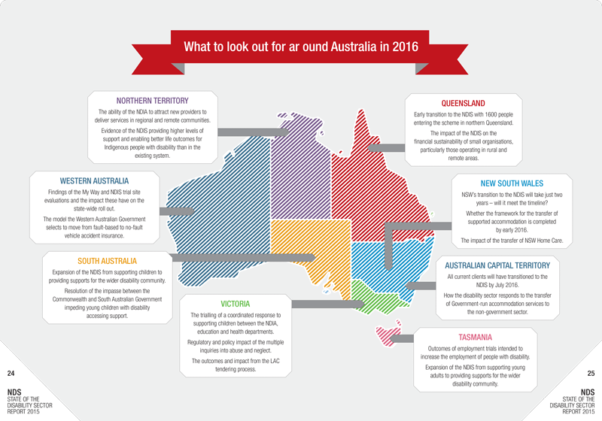

Provider readiness for the NDIS
The 2015 NDIS Provider Toolkit, a resource developed by NDS to help organisations understand the opportunities and risks involved with moving to the NDIS, shows that service providers continue to be challenged by this change.

Providers are least prepared on costing and pricing
Organisations proved to be most confident in data collection and storage practice, and financial reporting/ monitoring (both 78%). As in 2014, few organisations reported they were NDIS-ready on costing and pricing (20%). Marketing practice (21%) and HR strategy and workforce planning practice (22%) were also in need of development.

Trial site intelligence
NDS is closely monitoring the implementation of the NDIS in trial sites, disseminating information to assist service providers to make decisions about their operations.

Key findings

- The best outcomes occur when participants and families are informed.
- Business planning is impeded by the lack of market information about supply and demand from the NDIA.
- Organisations have found it is necessary to carry out risk analyses of participants’ plans.
- Organisations find the NDIA systems and processes time-consuming; these need to be streamlined before full implementation begins.
- Building strong relationships between the NDIA, disability support workers, participants, and their families and carers is critical to the success of the NDIS.

Funding the NDIS
The arrangements for financing the NDIS are complex, with the full roll out expected to cost $22B. As a shared Commonwealth/state initiative, it will require an estimated Commonwealth The NDIA approved an indexation contribution of around $11B each year. and Equal Remuneration Order (ERO) increase on 1 August which, for Victorian, NSW and Tasmanian trial sites, increased one-to-one hourly prices by $1.66 cents rather than $0.13 cents as originally announced. Other states received these increases for many prices, but in-home personal care and community participation were exempt The creation of an establishment fee for providers when they initiate services for new participants receiving more than 20 hours per month of one-to-one supports The reversal of an NDIA decision to cut prices for group-based support in centres and in the community The Commonwealth introduced the DisabilityCare Australia (DCA) levy from 1 July 2014. So far, the levy has raised more revenue than has been spent during the trial and transition phase of the scheme. The 2016 Federal Budget will be the first time the NDIS impacts the Commonwealth finances in forward estimates.

WORKFORCE SUSTAINABILITY

In the disability sector, almost 4 in 10 workers are employed on a casual basis. Workforce casualisation can result in inconsistency of support for participants, low investment in training and qualifications, and weak career pathways.
– Ken Baker

Recruitment methods are changing
Tailoring workforce profile to meet participant demand is a critical part of the workforce challenge. Providers report pressure to match the interests of participants with those of support workers.
This challenge is being met through:
New ways of working are emerging
There has been too little investment by governments to strengthen the leadership, management and culture within disability organisations.
At recent innovation workshops run by NDS, service providers shared models for:
Looking ahead
NDS has sought opportunities to influence the regulation of workplace relations in a way that would enable providers to respond flexibly to consumer demand while offering working conditions that attract and retain staff.
The final report from the Productivity Commission on the Workplace Relations Framework, due by the end of 2015, will recommend changes that may positively affect disability services, including:
In early 2016, the Fair Work Commission will commence hearings on the 2010 Social, Community, Home Care and Disability Services (SCHADS) Award.
The Modern Award review has conducted hearings on matters of relevance to the sector, such as part-time work and annual leave. Key issues for the SCHADS Award review include:

EMPLOYMENT SERVICES

Supported employment
The supported employment sector is going through a challenging time. Prolonged uncertainty is affecting confidence in ADEs and generating anxiety among supported employees and their families. The consequences of the 2012 Federal Court Business Services Wage Assessment Tool (BSWAT) decision continue to work through the Fair Work Commission, the Australian Human Rights Commission and other arenas, but the matter remains unresolved.
Despite this uncertainty, ADEs continue to deliver significant benefits to supported employees, their families and the broader community.
The future of ADEs is at risk
In 2015, NDS commissioned two reports examining wage setting and productivity in ADEs. Key findings include:
Negotiations are underway in the Fair Work Commission about developing a new wage assessment tool. Debate centres on the features of the new tool, its impact on wage costs, the implications for other wage assessment tools and the capacity of ADEs to pay wages after the Government’s wage subsidy expires.
NDS continues to work with the Department of Social Services on an industry development plan, including assisting organisations to prepare for the NDIS and develop viable businesses, as well as boosting government procurement from ADEs.
The closure of ADEs would deny thousands of supported employees the opportunity to work. NDS is engaged in the various arenas in which ADEs are under challenge, resisting any ‘resolution’ that would jeopardise jobs.
Open employment
The Disability Employment Services (DES) program is bound by almost 900 pages of rules and guidelines. Despite some relief from red tape in the past year, providers report that compliance is diverting resources away from direct service work.
In addition, DES providers have received no funding indexation since 2010, further reducing their ability to maintain the service levels required to meet demand from job seekers. Demand has increased significantly since the program was uncapped in 2010.
The system gives choice to government, not consumers
In 2014, the Commonwealth government planned to reallocate business from 24% of DES-ESS (Employment Support Services) contracts with lower Star Ratings. However, after pressure from NDS and the disability sector, only 11% of DES-ESS contracts were relocated. During this process, 7,200 participants (8%) transitioned to a higher performing provider.
With the impending roll out of the NDIS and a new Disability Employment Framework, it is critical that investment and effort focus on building the capacity of the sector rather than weakening it through further contract reallocation. Business reallocation empowers the Government to choose among providers, whereas the NDIS and the anticipated reform of disability employment support will give that choice to consumers.

POLICY AND RESEARCH
The National Disability Strategy needs energising
The National Disability Strategy is a ten-year plan agreed by COAG to promote the rights and inclusion of people with disability across all domains: health, economic security, learning and skills development, rights and justice, and accessible communities. But its effectiveness at driving change is weak. It needs a stronger performance and accountability framework including annual reporting to parliaments – state and federal. An action plan for 2015-18 is in development with a focus on the employment of people with disability, improved outcomes for indigenous Australians and increasing the awareness of the strategy.
Welfare reform should focus on jobs
The final report from the Welfare Reform Reference Group, chaired by Patrick McClure, recommended a suite of measures. This includes a restructure of the Disability Support Pension (DSP) – including a Jobs Plan – to increase employment for people with disability and mental illness.
Without recommending payment levels, the report suggests replacing the DSP with a Supported Living Pension and a tiered working age payment. A means-tested Supported Living Pension would be restricted to people with a work capacity of less than eight hours a week.
The report’s strength is its focus on employment. Pressuring people with disability to find work would be both unfair and futile unless accompanied by effective measures to increase the supply of jobs and the support available to people with disability. To date, most of the recommendations have not been implemented.
Not-for-profit reform must involve less red tape
In September 2014, the government introduced a Bill to repeal the Australian Charities and Not-for-profits Commission (ACNC). The Bill has not been passed making the long-term future of the ACNC look more secure.
There is now a centralised Australian Charities Register searchable by the public. For inclusion on this register, charities must submit an Annual Information Statement including financial statements.
An object of the ACNC is to reduce red tape for charities. Work on this continues as the ACNC negotiates with state and territory not-for-profit regulators on streamlining reporting requirements.
Competition policy requires careful application
In March, the government released the final report of the Competition Policy Review conducted by an expert panel led by Professor Ian Harper. The Review envisages community services as the next frontier of reform. NDS’s advice influenced the human services chapter and overall recommendations:
Contrary to competition principles, the NDIA’s request for tender for Victorian Local Area Coordination (LAC) services effectively excluded disability service providers. LAC services require an understanding of the impact of disability, strong local connections and a commitment to social inclusion, all attributes found among not-for-profit disability service providers. The NDIA was concerned about providers’ conflict of interest. The tender should have required providers to demonstrate how they would manage potential conflict of interest, rather than exclude them.
Preventing abuse and neglect is a critical issue
In response to continued concerns about safeguarding people with disability against abuse and neglect, a Senate Inquiry into violence, abuse and neglect in institutional and residential settings was established.
In November the Senate Inquiry released its report. The report includes 30 recommendations including calling for a Royal Commission, proposing a national disability complaints mechanism, increased national workforce and workplace regulation and improved access to justice for victims of abuse. NDS expects the government to respond to the report in 2016.
Similar Victorian investigations are underway with two early reports released. A report from the Victorian Ombudsman concluded that despite areas of good practice, oversight arrangements in Victoria are ‘fragmented, complicated and confusing’, arising in part from the ‘mishmash of legislative, financial and service delivery arrangements’.
Recommended as part of the Victorian Parliamentary Committee’s report is the establishment of a national independent body as part of the NDIS. This body would oversee responses to complaints, manage and investigate reportable serious incidents, oversee restrictive practices and administer a community visitors program.
Findings from these inquiries are expected to influence the design of the national quality and safeguarding framework for the NDIS.
Research and innovation
Evidence-informed policy and regulatory settings are essential for a strong disability sector. Building evidence requires research.
The 2014 Audit of Disability Research found that the current disability research agenda is fragmented and lacks a sustainable funding base. A mature research base with focus, depth, quality and coherence is needed.
Through the Centre for Applied Disability Research (CADR), NDS is helping to build research relationships with its members, academics, government and others with an interest in evidence-based policy and programs.

2016 TO-DO LIST
